Challenge description: I hope you like calculus :)

Give problems below.

$\frac{d}{da} [ \frac{1}{2} a^{2}]$

$\int{}[2n] dn$

$\frac{d}{dt} [\frac{1}{4} t^{4} + 3]$

$\int{}[4i^{3}] di$

$\frac{d}{d d} [\frac{1}{3} {d }^{6} + 6]$

$\int{}[6e^{5}] de$

$\frac{d}{d r}[\frac{1}{8} r^{8} + \frac{1}{6} r^{6} + \frac{1}{4} r^{4} + \frac{1}{2} r^{2} + r]$

$\int{}[8v^{7} + 7v^{6} + 4v^{3}+ 2v + 9] dv$

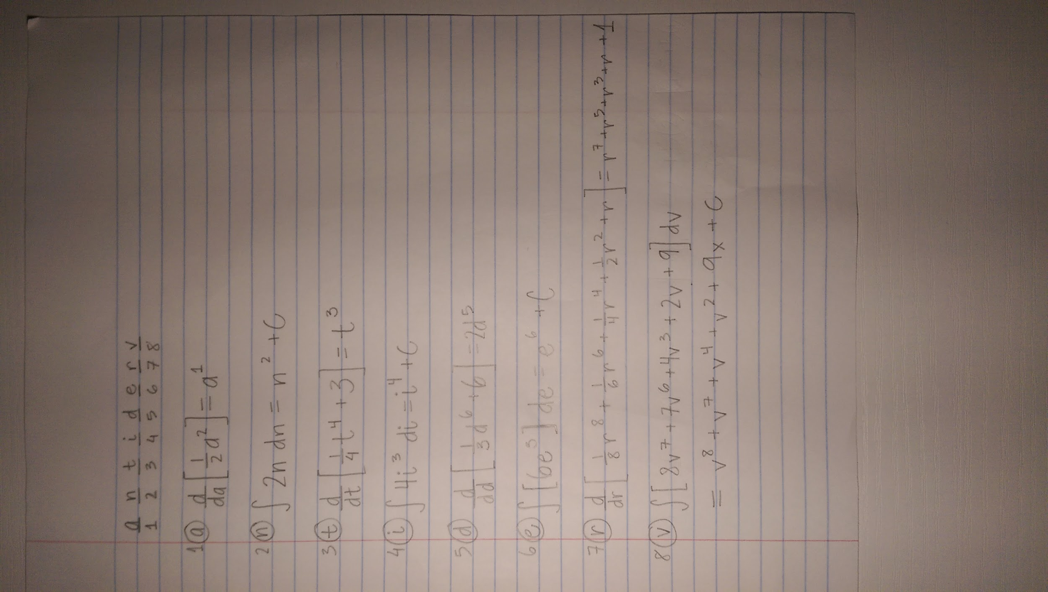

**Flag: antiderv**

**How to solve:**

* Solve the problems
* The (highest) exponent of the variable is the position number of the letter in the flag **antiderv**
  + Ex. For n
    - $\int{}[2n] dn$ = $n^{2}$
    - The position of letter n in the flag is 2

----------------------------------------------------------------------------------------------------------------------------

Substitution Cipher

Cipher Alphabet: **UdNfCOkPqYRwIvGxHjTAsBiLzE**

Plain text: In calculus, u substitution is a integration technique and is the counterpart to the chain rule of differentiation. If function f is continuous on a b then the flag is **antiderv.** For any constant c capital f plus c is an antiderivative for f.

Cipher text: qv nuwnswst, s tsdtaqasaqgv qt u qvackjuaqgv acnpvqhsc uvf qt apc ngsvacjxuja ag apc npuqv jswc go fqoocjcvaquaqgv. qo osvnaqgv o qt ngvaqvsgst gv u d apcv apc owuk qt **uvaqfcjb**. ogj uvz ngvtauva n nuxqauw o xwst n qt uv uvaqfcjqbuaqbc ogj o.